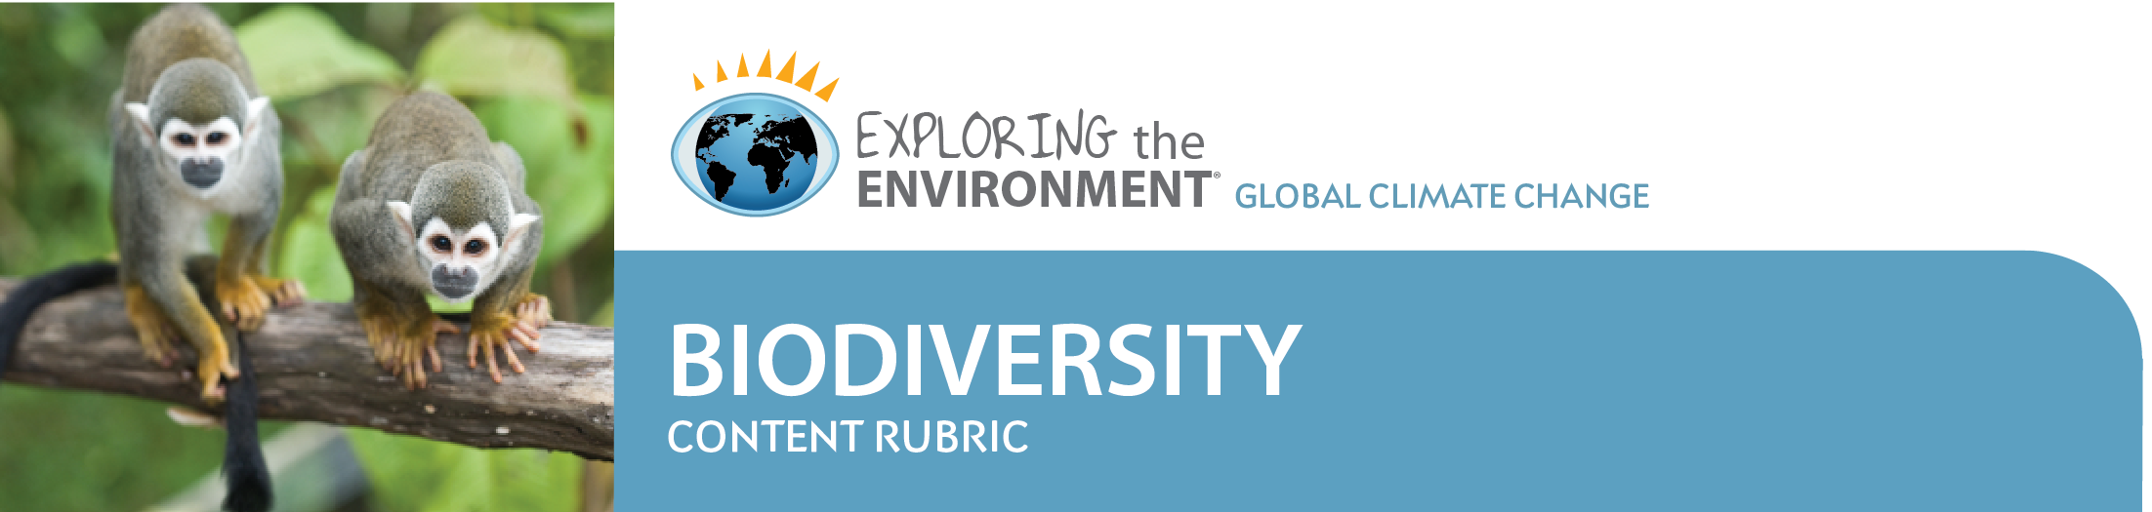

One of the most important strengths of problem-based learning (PBL) is its capacity to teach science content. Often, the focus of project work in some classes seems to be more on teamwork, communication, or the finished “product,” such as a report or a display. But problem-based learning in science involves more than that. It involves using critical thinking and problem solving to draw conclusions based on investigations of the science content. While you may still assess students' teamwork and communication efforts to help them improve these skills, you will likely want to assess their science learning in more detail.
Assessment of student mastery of content through rubric construction is objective and efficient. Rubrics should be developed and tailored to meet the needs of the unique class. For example, no one rubric could meet the needs of assessing both a 9th grade integrated science class and a 12th grade environmental science class. Obviously, the students in the 9th grade class lack the research, critical thinking skills, and content knowledge expected of the seniors.
An example of a rubric to assess student content learning for the Biodiversity module is provided below. It lists several outcomes of student work for science research, analysis of data, and science content knowledge to help guide you in assessing students' level of mastery. Adding specific objectives for each of your classes will help in assessment and in letting your students know what is expected.
Science Research/Sources (25)
- A variety of sources were used to locate relevant data on Earth’s biodiversity.
- The research was complete enough to support student conclusions.
- Conclusions are based on thorough research, not on limited information.
- Varied and reliable resources were used.
- Sources are provided.
Score ________________
Analysis of Data (25)
- Data were analyzed to identify trends occurring in biodiversity.
- Presentation incorporates relevant tables and graphs to support conclusions.
- Data are sufficient to support conclusions.
- Student shows an understanding of the graphs and tables and can speak knowledgably about the analysis.
- Student uses scientific data to support a position on biodiversity as an environmental issue.
- Data used are well selected to support the position.
- Data and supporting graphics extend beyond the basic.

Score ________________
Science Content knowledge (50)
- Student explains the impacts of changes in global climate and understands these changes may be long reaching and slow to develop.
- Variables in climate change are clearly recognized.
- Student demonstrates an understanding of the background information on the causes of climate change, potential effects, and the concept of global carbon sinks and sources and their significance to Earth’s climates.
- Student describes underlying environmental mechanisms that drive biodiversity on Earth.
- Student identifies causes of increased global mean temperatures.
- Student explains the importance of a rich biodiversity and possible consequences of biodiversity loss.
- Student explains the impacts of environmental changes on biodiversity and why species may respond negatively to those changes.
- Student describes both short- and long-term impacts of a loss of biodiversity to ecosystems and their inhabitants, including plants, animals, and humans.
Score ________________
Note:
- Several types of rubrics for assessing teamwork and behaviors during problem-based learning assignments are included in the Teacher Pages for Global Climate Change modules.
- Developing Rubrics at http://ete.cet.edu/gcc/?/pbl_developing/ presents an overview of the benefits of rubric use when assessing student PBL work and also presents an example of some Guidelines for Developing a Rubric by Donna Szpyrka and Ellyn B. Smith of Florida's Statewide Systemic Initiative.
- Assessment in Global Climate Change PBLs at http://ete.cet.edu/gcc/?/pbl_assessment/ discusses the importance of involving students in the assessment process at the beginning of their problem-based learning work. This allows students to work more productively, gives them a clearer idea of what they are supposed to be learning, and reduces their stress about how they will be evaluated.
- Assessing Behavior in PBL Projects at http://ete.cet.edu/gcc/?/pbl_assessingbehavior/ provides examples of rubrics that can be used to assess team and individual responsibility.

